Name ________________________ Georgia Southern decides to build a new **400 meter track** that contains 2 straight sections and 2 semicircular ends. In order to play soccer on the enclosed field, they want to maximize the area of the perfect rectangular region that separates the semicircular ends.

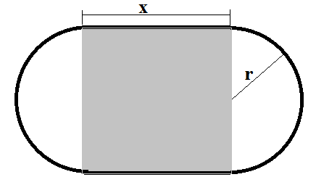

1. Draw the region and label the drawing using x for the straight sections and r for radius. Also shade the perfect rectangle referred to in the directions.
2. What kind of units will be used for the phrase “**400 meter track**”? m, m2, m3 m
3. Write the secondary equation that describes **400 meter track** and solve for x.

2x + 2 r = 400 x = 200 –  r

1. Underline the optimization word and the next 2 words in the problem.
2. What letter should we use for the third word underlined? A
3. State the units for that word. m2
4. Write the primary equation. A = 2 r x
5. Replace the primary x with your answer to 3. A = 2 r (200 –  r)
6. Differentiate the primary and set equal to zero. A’ = 400 – 4  r = 0
7. Solve for r. r = 100/   
8. Solve of x (see #3) x = 200 –  r = 100 m
9. Prove that your answer is a local maximum. A’’ (r)= - 4 

A’’(100/ = – 4  => local max

1. What would the primary equation be if the problem said “maximize the total area enclosed by the track”? TA =  r2 + 2  x
2. Substitute x ( see no 3.) into the new primary. TA =  r2 + 2 r (200 –  r)
3. Differentiate and set equal to zero.
4. Solve for r and x ( see no 3.).

TA’ = 2 r + 400 - 4  r = 0 r =200/   or x = 0

1. What is the shape of this track? Perfect circle